Scope of Work
Submitted to Chris Pennell
Manager, Technical Analysis
Utah Division of Air Quality
Title: TRAX Air Quality Observation Project
Project Period: 1 July 2019-30 June 2020
Investigators: Daniel Mendoza, Logan Mitchell, John Horel, John Lin
Department of Atmospheric Sciences
University of Utah

- Project Background

Utah’s Wasatch Front experiences poor air quality episodes during both summer and winter due to its unique weather, topography, and pollutant emissions. During winter, inversions trap unhealthy concentrations of fine particulate matter (PM_{2.5}), while high pressure during summer leads to elevated ozone (O₃) levels. Air quality resources along the Wasatch Front include fixed sites from the Utah Division of Air Quality (UDAQ) and University of Utah (U of U) researchers. Four years ago, we deployed air pollution sensors during a pilot project on two TRAX light rail cars that traverse the Salt Lake Valley on the Red and Green lines.

Only a few mobile urban observation networks leveraging public transit currently exist worldwide: Zurich, Switzerland (Hasenfratz et al., 2015); Karlsruhe, Germany (Hagemann et al., 2014); Oslo, Norway (Castell et al., 2015); and Perugia, Italy (Castellini et al., 2014). Each of these projects have different experimental designs with a different suite of measurements, and while their utility is still being explored, it has been shown that public transit based monitoring can be used to create high-resolution maps of air pollution across urban areas (Hasenfratz et al., 2015). The TRAX air quality monitoring effort is the first to utilize public transit for urban observations of trace species in North America.
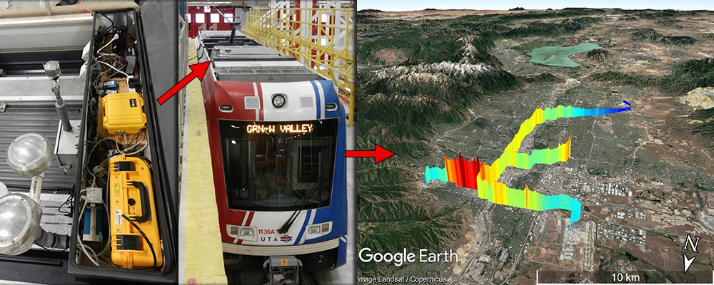
Figure 1. Schematic showing the TRAX instrumentation box, a TRAX train, and a Google Earth plot of the data along the red and green lines.

As described by Mitchell et al. (2018), the Utah Transit Authority (UTA) “TRAX light rail train network consists of over 145 electric trains servicing three lines (Red, Green, and Blue) along 94 km of rail track that provide coverage across the SLV (Figure 1). Urbanization along the rail lines varies from dense urban downtown regions to suburban and rural settings, and the train travels on and off major roadways. TRAX operates an older model of rail car on the Blue line, so our historical data from the past 4 years are only from the Red and Green lines. Along the Red, Green, and Blue lines there are 25, 18, and 24 passenger stops, taking 60, 46, and 48 minutes, respectively, to complete a transect on each line. In addition to the spatial coverage, the Red line also provides a 225 m pseudo-vertical profile from the valley floor (1,285 m) to the surrounding mountain foothills (1,510 m). Each TRAX train car covers 18-24 transects when operating for a full day (approximately 18 hours from 5 AM to midnight). During the period December 2014 – April 2017, the trains were deployed 760 days comprising 10,300 transects on the green and red lines (averaging 14 transects a day and deployed 61% of days, or ~4 days a week). When the trains were not in operation, they were often parked outside and therefore became periodic stationary observation sites that provided additional observations.

This statement of work is for a new, third box to be installed in summer and fall 2019 on the TRAX Blue line. The addition of the Blue line train will provide coverage in previously unobserved locations in the southern and eastern portions of the Valley between Sandy and Draper, potentially capturing inter-basin exchange processes as air enters the Salt Lake Valley from the Utah Valley through the Jordan Narrows.
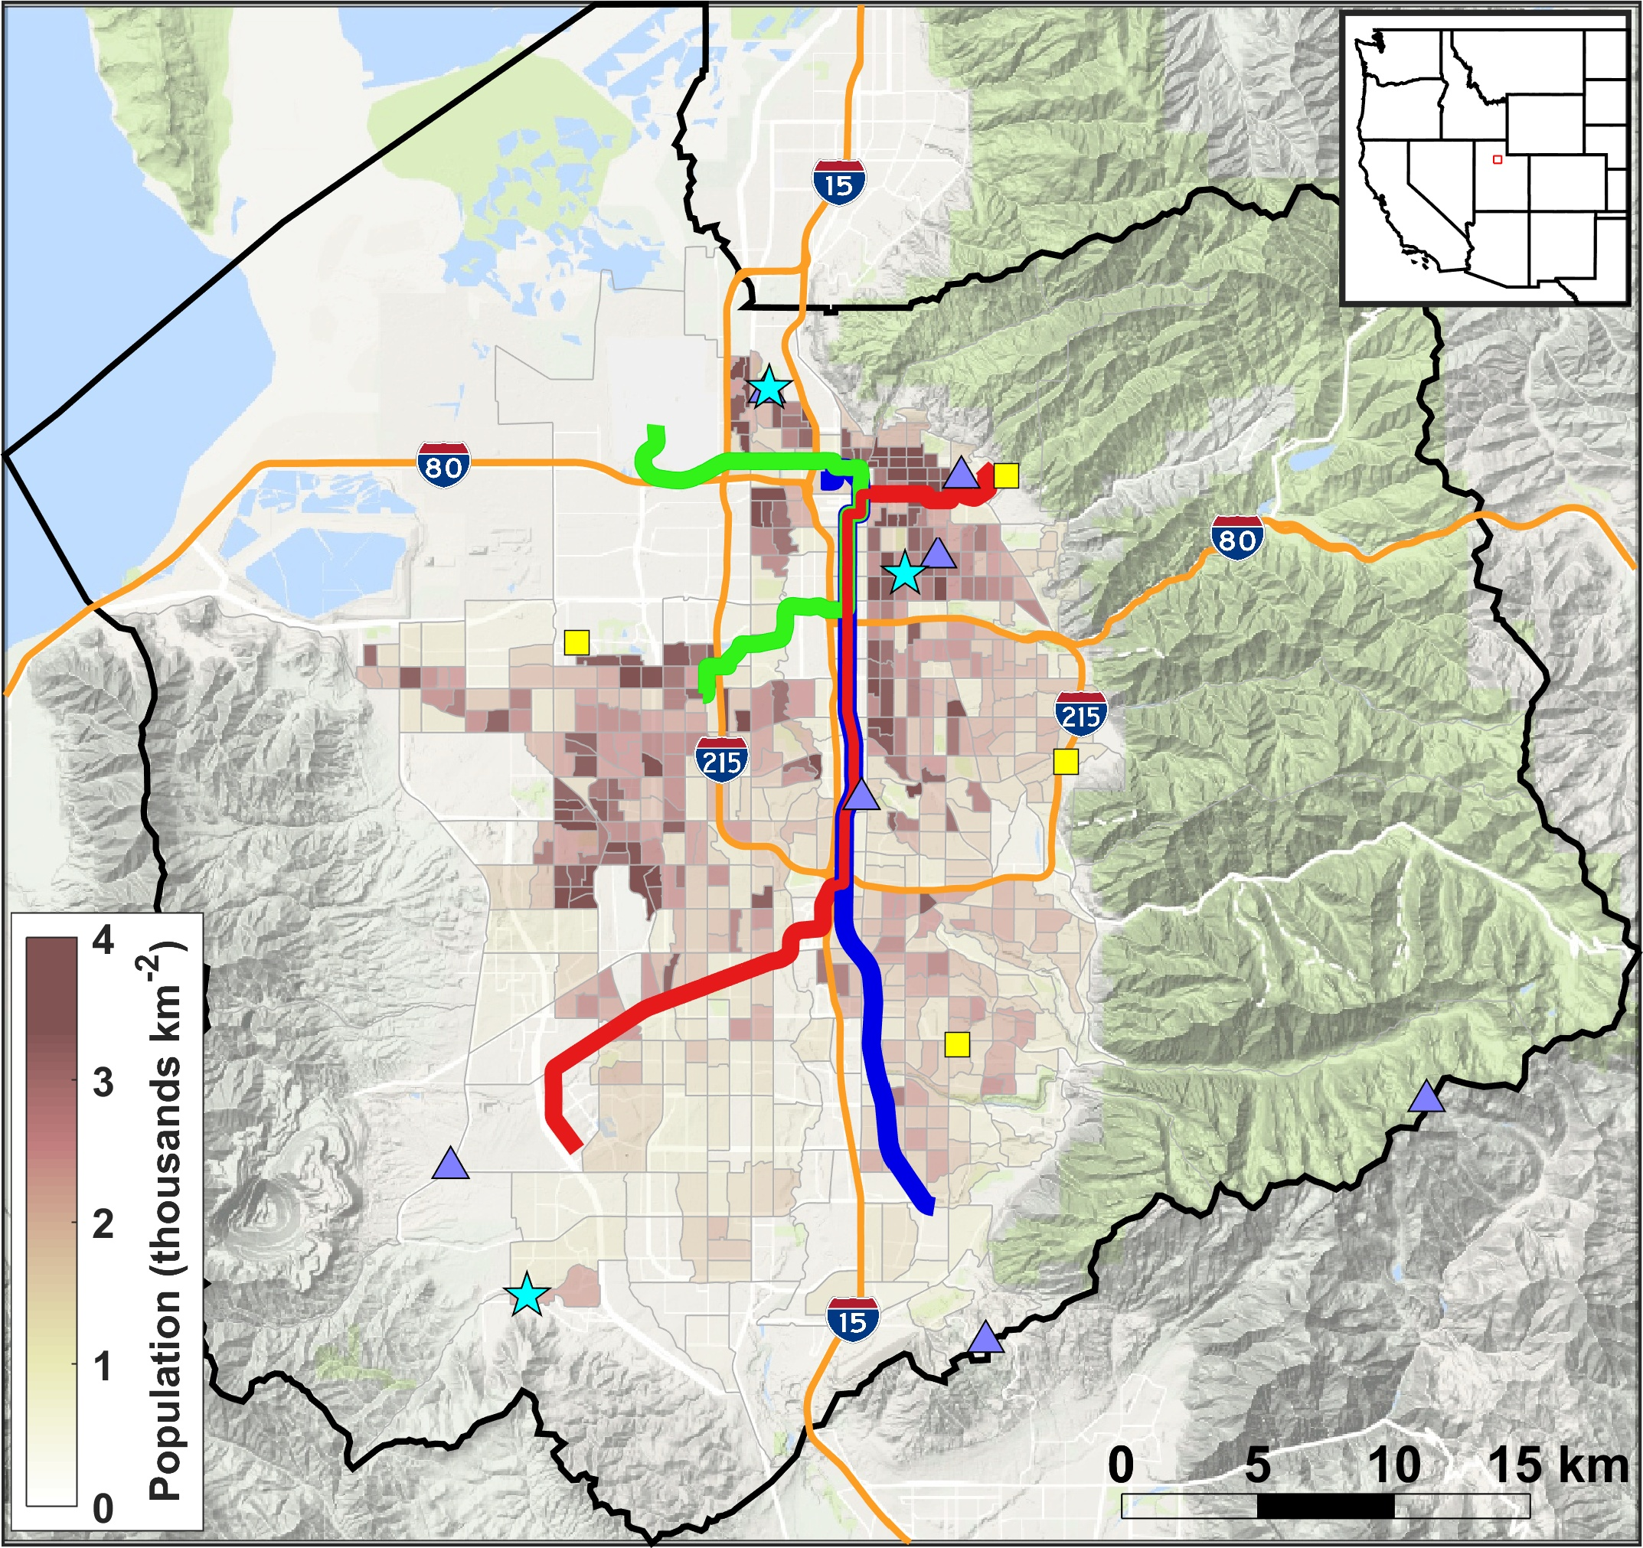
Figure 2. Map of the Salt Lake Valley showing the TRAX Green, Red, and Blue train lines.

TRAX is a unique platform available to capture spatial variations in ozone and PM_{2.5} when the light rail cars are operating. The three-year pilot program to test and evaluate the deployment of the sensors and real-time availability of the air quality monitoring has been a success and resulted in legislative support for this project that is expanded from last year’s support of the red and green line trains to the addition of a blue line train this year to expand the spatial benefit of the TRAX air quality project observations.

- Deliverables

The specific deliverables that will be provided during the July 1 2019- June 30, 2020 project period are as follows:

- Installation and operation of new calibrated research grade or better PM_{2.5} and ozone sensors on a box on a blue line TRAX light rail train car
- Online real-time visualization of TRAX blue line air quality measurements alongside similar measurements from the red and green lines
- Publicly-accessible archive of blue line TRAX air quality data for download in a format easily accessible to researchers (e.g., not PDF or image scans)
- Quality control and rigorous validation of TRAX blue line PM_{2.5} data against fixed site UDAQ Hawthorne PM_{2.5} measurements
- Copy of the quality-controlled data archive for archival with UDAQ
- Quarterly reports that summarize the status and progress of all aspects of this project

Additional details regarding these deliverables follow.

- Installation of Air Quality Instrumentation on TRAX Blue Line

The following instrumentation has been proven to be accurate and robust on the TRAX train on the Red and Green Lines (Mitchell et al., 2018). Thus, we propose to utilize the same proven instrument setup on the green line as used on the other lines. Electrified trains are an ideal platform for air sampling because they have zero direct emissions and run continuously throughout the day whenever they are operating. The trains have electric circuitry on their roofs in steel weatherproof boxes, and our instruments were installed in one of the spare boxes (dimensions 1.5 m x 0.5 m x 0.5 m). The sample inlets extended 0.5 m above the top of the train through a pipe protruding from the metal box topped with a vent cover and were 4 m above ground level. AC power was provided with a connection into the main power through an inverter. Two generic computer fans provided cooling for the instruments in the box in the summer. Table 1 lists the equipment that will be installed on both of the TRAX trains, as well as the instrumentation sampling frequency and their measurement accuracy.

Table 1
Measurement equipment for PM_{2.5} and Ozone to be purchased and deployed on TRAX train cars.
Instrument | Species | Sampling rate | Measurement uncertainty
Met One Instruments ES-642 Remote Dust Monitor | PM_{2.5} | 1 sec. | 1 µg m⁻³
2B Technologies Model 205 Ozone Monitor | O₃ | 2 sec. | 2%

- Data Collection, Storage, Archival, and Dissemination

A key deliverable of the TRAX data system is real-time and archived data available for the public, UDAQ, and other scientists. Part-time technicians will be dedicated to keeping the instruments in working order on both trains at all times, assisting with the fixed calibration sites, and developing the data archive and public access web interfaces. The air quality observations are collected every 2 seconds and transmitted to U of U servers via cellular communications every few minutes from onboard dataloggers. The data are then archived on Network File System (NFS) mounted servers at the Center for High Performance Computing (CHPC) at the U of U.

- Data Validation, Calibration, and Quality Control Procedures

A key new component of this study is establishing careful data validation, calibration, and quality control procedures for the TRAX data. This will be conducted this year for the Red and Green line TRAX data, and will be included in the data collected on this new sensor suite on the Blue line as well. A fixed tripod with an ES-642 PM_{2.5} sensor that was placed at the UDAQ Hawthorne Elementary School site beginning in November 2018 will continue to provide a baseline comparison of the measurements of the ES-642 Nephelometer to the UDAQ Federal Equivalent Method (FEM) measurements. A second fixed tripod with ES-642 sensors that was placed along the TRAX lines at ~1800 south in the Salt Lake Valley beginning in November 2018 will also be used to further calibrate and validate the blue line train instrumentation suite. Regular calibration, comparison, and validation of the TRAX sensors with the fixed sensors will be carried out. This will allow for careful quantification of any errors and biases in the TRAX measurements relative to UDAQ Hawthorne PM_{2.5} measurements, as well as to ascertain that instrument drift, fog, smoke, and other environmental factors that could potentially impact the TRAX measurements are carefully documented and quantified. The ozone instruments will be calibrated bi-monthly using a calibration unit recently obtained through a University instrumentation grant by the University of Utah Atmospheric Trace gas and Air Quality (U-ATAQ) laboratory (https://air.utah.edu/).
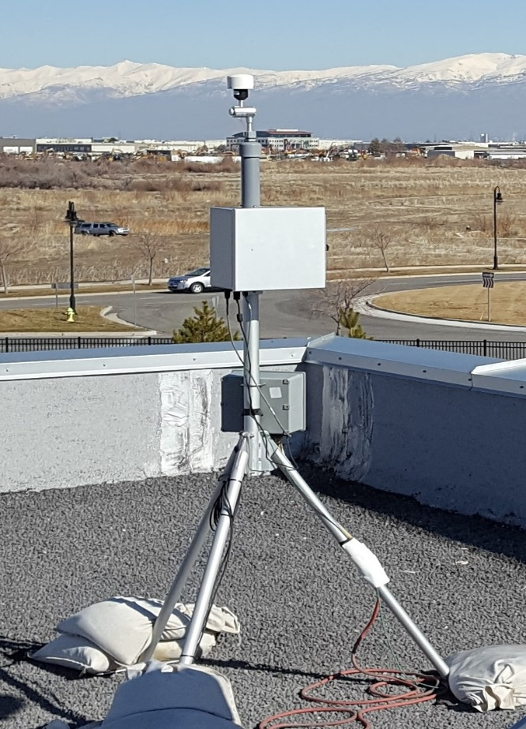
Figure 2. Example validation PM_{2.5} sensor with a tripod.

- Performance Measures and Quarterly and Annual Reporting

The performance metrics will focus on the effectiveness of providing the TRAX air quality data set to UDAQ, the public, state government, and scientific community, as well as the quality (calibration and maintenance of instruments) and dependability (no outages) of the data provided. The various performance measures will be summarized in an annual report on the TRAX project that will be submitted to the Utah Division of Air Quality (UDAQ). In addition to the annual report, we will provide quarterly reports that summarize the status of all aspects of this project.

Budget (07/01/2019 - 06/30/2020) and Budget Justification

Personnel Costs: Management and science and QC | $7,029
Personnel Costs: Technician(s) | $5,200
Fringe Benefits (37%) | $4,525
Instrumentation systems (Excluded from Indirect Costs) | $16,500
Lab/technical supplies, and repairs/maintenance | $926
Communications equipment and dataloggers | $3,000
TRAX train box (on top) that houses instruments | $2,000
Other expenses (cellular modem fees, truck rental, etc.) | $1,320
Sensor system repairs/calibration | $1,000
Total Direct Costs |  | $41,500
Indirect Costs | $2,500
Total Costs |  | $44,000

PERSONNEL

Salary support for 1.5 weeks for Research Assistant Professors Mitchell and Mendoza to oversee the installation of the sensor suite on the blue line. Also 1 week of support for staff scientist Ben Fasoli and postdoctoral researcher Alex Jacques to assist with data ingest and web site display. Also support for 2 technicians (1.5 cal. mos. total) to assist with instrument installation and testing as well as quality control, calibration, validation, archival, and public dissemination of the data obtained.

FRINGE BENEFITS
The fringe benefit rate for full-time faculty/staff is calculated at 37%.

NEW INSTRUMENTATION SYSTEMS total: $16,500

New systems to be installed for PM_{2.5} and O₃ on the blue line TRAX light rail train car

COMMUNICATION, SUPPLIES, REPAIRS, CALIBRATION, MISC total: $8246

Monthly cellular modem fees, power inverter, metal box on top of the train to install the instruments in, truck rental, miscellaneous cables, tripod and tripod parts, tools, filters, hoses, instrument repairs and maintenance.

INDRECT COSTS
University of Utah indirect costs are calculated at a rate of 10.0% of a Modified Total Direct Cost (MTDC).

8) References

Castell, N., Kobernus, M., Liu, H.-Y., Schneider, P., Lahoz, W., Berre, A. J., & Noll, J. (2015). Mobile technologies and services for environmental monitoring: The Citi-Sense-MOB approach. Urban Climate, 14, Part 3, 370–382. https://doi.org/10.1016/j.uclim.2014.08.002
Castellini, S., Moroni, B., & Cappelletti, D. (2014). PMetro: Measurement of urban aerosols on a mobile platform. Measurement, 49, 99–106. https://doi.org/10.1016/j.measurement.2013.11.045
Hagemann, R., Corsmeier, U., Kottmeier, C., Rinke, R., Wieser, A., & Vogel, B. (2014). Spatial variability of particle number concentrations and NOx in the Karlsruhe (Germany) area obtained with the mobile laboratory ‘AERO-TRAM.’ Atmospheric Environment, 94, 341–352. https://doi.org/10.1016/j.atmosenv.2014.05.051
Hasenfratz, D., Saukh, O., Walser, C., Hueglin, C., Fierz, M., Arn, T., et al. (2015). Deriving high-resolution urban air pollution maps using mobile sensor nodes. Pervasive and Mobile Computing, 16, Part B, 268–285. https://doi.org/10.1016/j.pmcj.2014.11.008
Mitchell, L. E., Crosman, E. T., Jacques, A. A., Fasoli, B., Leclair-Marzolf, L., Horel, J., et al. (2018). Monitoring of greenhouse gases and pollutants across an urban area using a light-rail public transit platform. Atmospheric Environment. https://doi.org/10.1016/j.atmosenv.2018.05.044

